Definition
An LDR is a passive semiconductor device whose resistance decreases as light intensity increases.

Working Principle (Photoconductivity)
An LDR works on the principle of Photoconductivity.

Step 1 – No Light (Dark Condition)
- Very few electrons are free.
- Current cannot flow easily.
- Resistance becomes very high.
Result:
- High Resistance
- Low Current

Step 2 – Light Falls on the LDR
When light falls on the LDR,
- Light particles (Photons) strike the semiconductor material.
- Electrons gain energy.
- More free electrons are created.

Step 3 – Conductivity Increases
Because more free electrons are available,
- Current flows more easily.
- Resistance decreases rapidly.

Step 4 – Arduino Reads the Voltage
The LDR and the 10kΩ resistor form a Voltage Divider.
Arduino reads the voltage at A0.
Depending on the light level,
- Dark → Lower Analog Voltage (according to this circuit configuration)
- Bright → Higher Analog Voltage
Arduino compares this value with the threshold and controls the LED.

LDR circuit tutorial with Arduino Uno

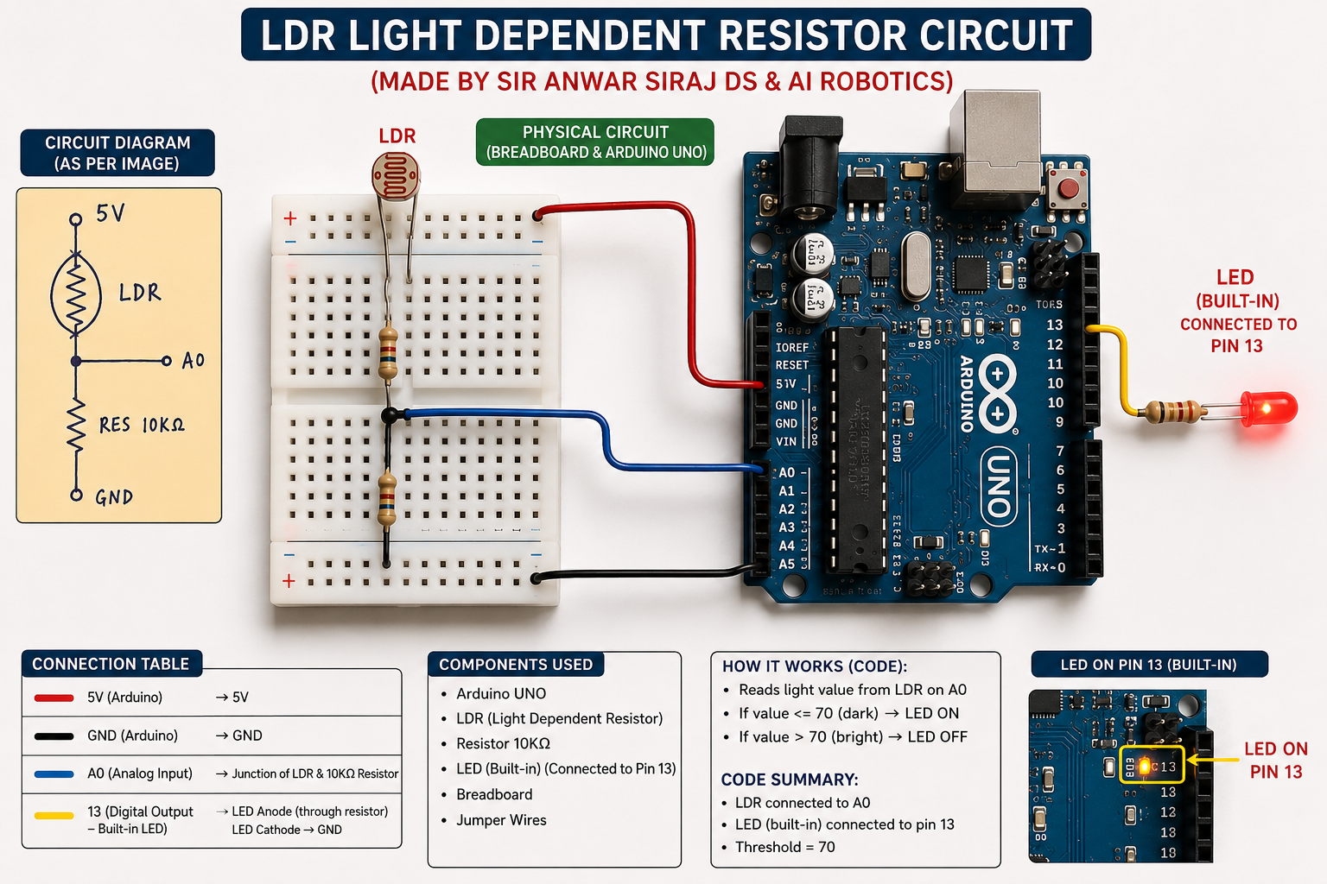

//CODE
// MADE BY SIR ANWAR SIRAJ DS & AI ROBOTICS

int ldrPin = A0;
int led = 13;
int threshold = 70;
void setup()
{
Serial.begin(9600);
pinMode(led, OUTPUT);
}
void loop()
{
int data = analogRead(ldrPin);
Serial.println("");
Serial.print("Light Sensor ");
Serial.print("Value = ");
Serial.print(data);
if(data <= threshold)
{
digitalWrite(led, HIGH);
}
else
{
digitalWrite(led, LOW);
}
}

